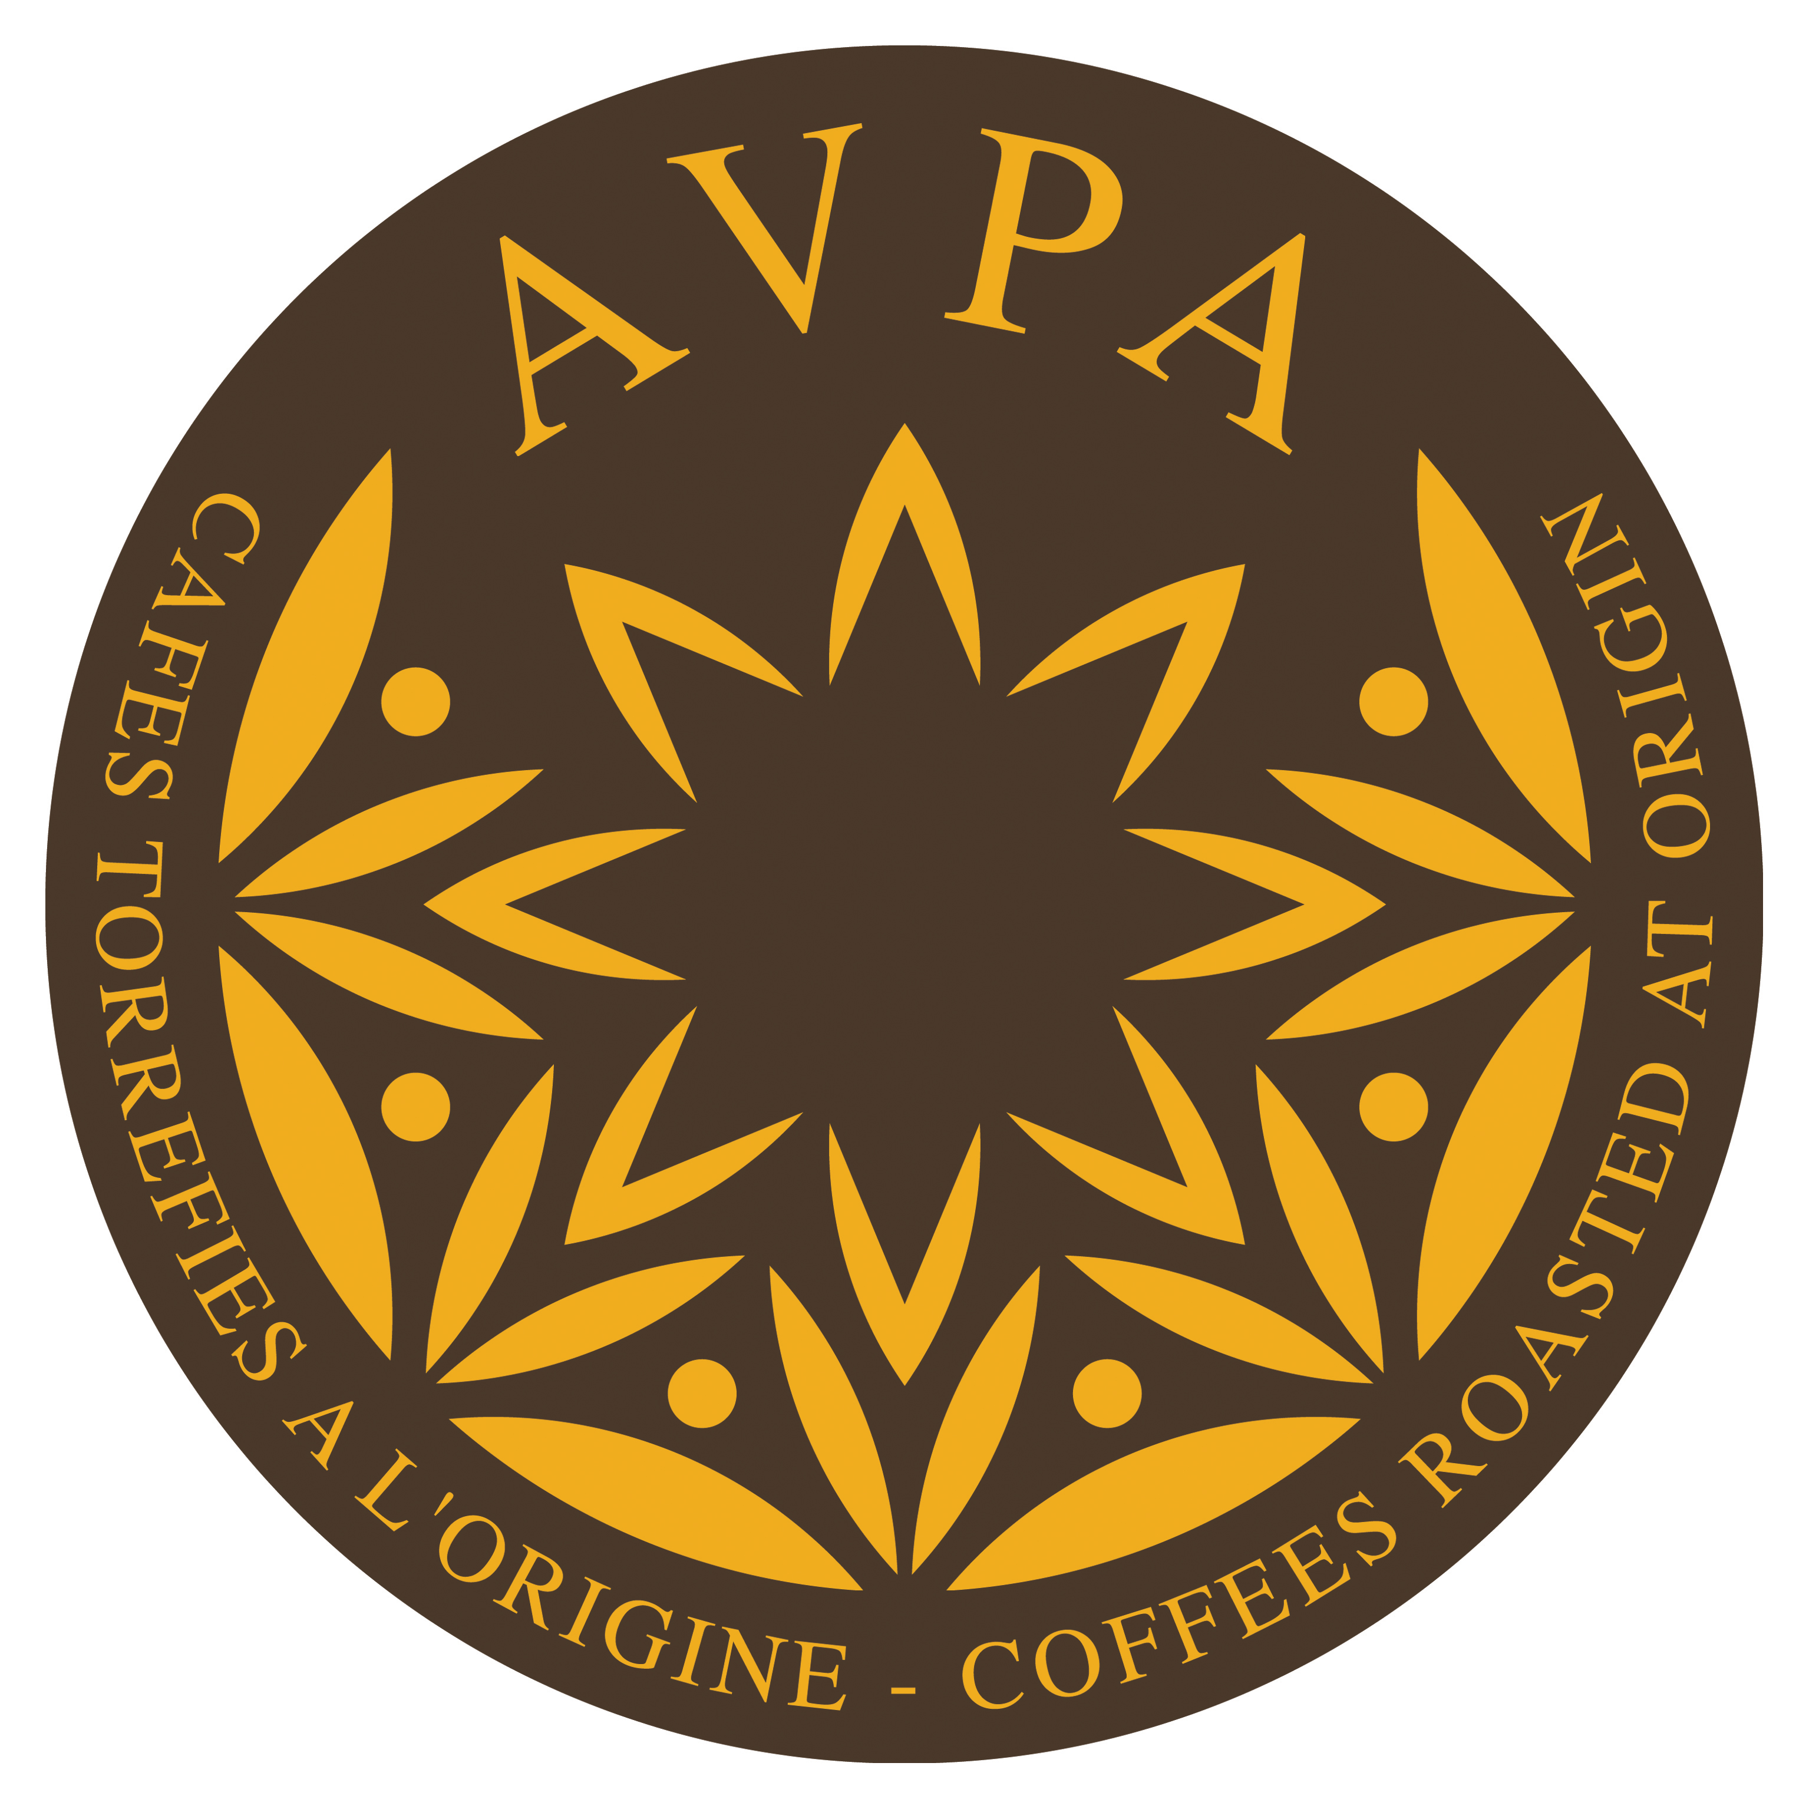
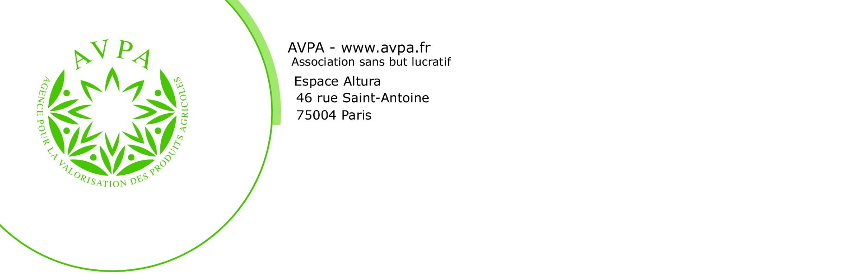

7th International Contest of “Coffees roasted at origin” AVPA-Paris 2021

Rules and regulations updated on October 31st, 2020

The Agency for the Valorization of Agricultural Production - AVPA is organizing a contest in order to enable producers to improve consumer perception of exceptional organoleptic properties of specific coffees, attained when the latter are cultivated and roasted properly by the producers, i.e. with an attention similar to the one given to other exceptional products such as wine and olive oil for example.
The general principles governing this contest are as follows:
- There is not one template for coffee and it would be wrong to speak of the world's best coffee. On the contrary, there are homogeneous coffee categories and it is possible, in each category, to determine the coffee or the coffees that are best expressing the character and properties of the concerned category.
- The preparation of coffee can dramatically change its perception. By controlling its roasting, the producer becomes the master of the product that will later be infused. Nevertheless, it remains necessary to follow cup preparation methods which will allow to properly judge the coffee’s best features. For this purpose, we shall propose two preparation methods that will best suit the participant’s criteria.
In order to ensure complete transparency and equal opportunities for the participants, AVPA established these rules and regulations in French, Spanish and English. The document will be available to anyone upon request.

Art 1: Participants

Any company can participate in the contest, regardless of its legal nature and its purpose. Nevertheless, it must:
- Be able to inform the Contest Organizers of the geographical origin of the coffee presented in the competition,
- Certify that the roasting was carried out on the farm where the coffee was grown or under his direct responsibility in a roasting facility chosen by him, or certify that the roasting was done in the province or country where the coffee was harvested,
- Be the owner of the trademark or of the coffee name presented in the competition.
Will only be taken into consideration the companies that have:
- Updated their contribution fees and participation costs
- Adequately filled their "registration form" (see below)
- Sent the necessary samples under the required conditions
By the simple fact of completing and signing their contest registration form, participants agree to accept these Rules, which they have previously read.

Art 2: The Jury

The AVPA jury consists of six to twelve members. The jury members are French speaking; they are professionals of the coffee industry (producers, roasters, and distributors), chefs, gourmets and discerning consumers. The main features of the jury are:
o its cultural and linguistic homogeneity,
o its plurality, since it includes:
- Coffee experts
- Taste experts
- Well-informed amateurs.
Consequently it also contributes to the gastronomic culture and to a good "French" taste, reaching a certain form of universalism by the high competence or gastronomic expertise of its members, who can put forward exceptional productions.

The President of the jury is appointed by the AVPA secretariat. He agrees on the final constitution of the jury and the operative modalities of this jury.

The jury is comprised of “a Technical Committee”, of at least three members, involved in the pre-classification of the competing coffees.

The jury's decisions are final and no claims will be accepted.

Art 3: The coffees in the contest

Coffees shall be tasted following two methods: Espresso method and/or Direct brewing method in a bowl.
AVPA will prepare the roasted coffees using the following criteria:

- Neutral water temperature between 80 °C and 95 °C, according to the requirements of the participants
- Uniform grinding for all coffees in competition (taking into consideration that grinding will be adapted to each preparation mode).
- Volume of water and coffee weight:
- Espresso Coffee 14 g of coffee for two cups of coffee each one of 6 cl to begin. Then the jury will determine the optimal parameters for the best cup.

- Direct brewing Coffee: 15 g per 25 cl bowl of water.

- Pressure of Espresso Machine: 9 bars – Brewing time: 22 seconds (+ or – 10%) to begin. Then the jury will determine the optimal parameters for the best cup.

- Infusion time (Direct brewing method): 5 minutes
It is the participant’s responsibility:
- To choose the most appropriate method for the quality of his coffee
- To roast the coffee optimally according to the preparation method ()
- To specify to the organizer the water temperature that he considers optimum for the brewing of each coffee proposed for the competition
- To send 500 grams (or 1lb) of coffee beans samples for every competing coffee and each method of preparation.
- To fill out the participation form which will be given to him/her, highlighting in particular:
- The botanical variety or varieties of the coffees;
- The cultivation methods;
- The roasting/processing method;
- The volume of coffee of the same characteristics harvested and roasted during the last coffee year;
- If the coffee is certified "organic" or "fair trade", a copy of the certificates must be sent with the samples.
Art 4: Classification

Coffees will be classified according to their type of production and the type of preparation desired:

- Class 1: Production type
Production type refers to the socio-economic model guiding the preparation of the sample sent. 3 groups have been selected:

4.1.1. Estate Coffee - Coffee from a single estate, roasted in the property where it was harvested or, at least, under the responsibility of the farmer.

4.1.2. Regional coffee - Coffee presented by a regional roaster living in the Province from which are issued the green coffees roasted and shown in the contest. Especially suited in case of Geographical Indication (GI).

4.1.3. National coffee - Coffee presented by a nationwide roaster residing in the country from which are issued the green coffees roasted and presented in the competition.

- Class 2: Type of preparation required

Two preparations were selected:

4.2.1 Roasted coffee for "filter" type preparation (direct brewing in a bowl)

4.2.2 Roasted coffee for espresso preparation

Within these 3 x 2 = 6 groups, coffees are divided between homogeneous tasting families limited to 9 categories which probably represent, at least partly, the well-known professional classifications (Robusta coffees and Arabica coffees, natural, semi washed and washed coffees).

Art 5: Definition of the evaluation criteria in each family

The Technical Committee will set up homogeneous groups according to the so-called “napping” method and it will be free to compose as many families as necessary in order to define the organoleptic world of the samples received.
For each group, the jury will define the desired qualities and disqualifying faults. Each family has its own, specific tasting sheet. For example, acidity (provided it is not excessive) can either be considered as a quality or a defect according to the family. According to the number of participants, a separate tasting process will take place to classify certified coffees.
Coffees organized in this way that have no disqualifying fault according to the criteria of the corresponding family will be presented to the Jury for tasting and evaluation.

Art 6: Tasting

- The tasting will take place in an isolated and quiet space without fragrances or parasite flavors;
- The President of the Jury, assisted by a member of the Technical Committee, will conduct a sequential organization of the tasting for the Jury member to help them to fully appreciate the unique qualities of each coffee:
- Each member of the Jury will have at his/her disposal the necessary elements for both tasting and rating;
- If necessary, the President of the Jury may request for a new degustation, possibly using a new cup, in order to decide between very similar coffees, or in case of sensing "abnormal" tastes.
Art 7: Evaluation

- Each member of the jury will grade the coffees in the contest with a predefined tasting sheet, one per family:
- Particular attention will be paid to the original notes, tending to promote coffees with strong personality and thus character:
- Each characteristic is rated from 1 to 5 depending on its intensity and will be balanced, using a specific co-efficient for each family of coffee;
- Each tasting sheet is given to the President or the Secretary appointed by him who calculates an arithmetic average of the scores given to each characteristic, for each of the coffees, to obtain the final grade.

Art 8: Distinctions

For each category the Jury deliberates sovereignly based on ratings defined above and determines the distinctions awarded to competitors.

It selects the coffees that can receive the "Product Gourmet AVPA 2021" qualification which will lead to an official diploma.

Among gourmet products of each class, the Jury may give to the best of each category one of the following medals: Gourmet Or, Gourmet Argent or Gourmet Bronze (Gold Gourmet, Silver Gourmet or Bronze Gourmet). These awards will be materialized by a trophy and confirmed by a certificate.

The jury is sovereign in determining the number of medals and certificates. It also has the prerogative to assign any special distinction that would be given to a particular coffee or a deserving producer.

Art 9: Awards ceremony
The Contest Organizers will determine, in time, the exact dates of the various steps of the competition which will be wrapped up by a ceremony in Paris. During this ceremony the nominated coffees are announced and prizes are given to the award winning coffees.

This ceremony may possibly be duplicated, especially in other countries of consumption or in countries or regions of production, at the request and expense of the participants.

Article 10: Competitors obligations
The participation in the contest implies the competitor accepts the present rules as well as the jury’s
decisions.
The competing coffees must not contain chemical additives and must respect the good practices
recognized by the trade.
The coffee roaster must send samples of the year with all the roasted coffee characteristics according to the registration form.
The coffee roaster commits himself to respect the financial terms of the registration form.
The coffee roaster accepts that his name can be released and published by AVPA while issuing the contest results.
The coffee roaster commits himself to show his diploma or medal on any stand of any show or trade fair he will attend, for at least one year following the date of his reward.
After the contest in order to participate in the association promotion effort the awards winners commit themselves to send to AVPA for each awarded coffee a number of gift packages in selling units of coffee in beans as follows :

Estate coffee: 20 packages - Regional coffee: 50 packages - National coffee: 100 packages

The coffee roaster commits himself to respect the conditions of the license contract issued each year by AVPA in order to be allowed to use the obtained rewards on his labels.

( ) The degree of roasting varies widely across countries and regions. AVPA has produced a guide on "Roasting methods in Europe", which is available to participants

